**Name**: Chimaroke Amaike

**Student ID:** 21085699

**Course:** Applied Data Science 1

**Course Code:** 7PAM2000-0901-2022

**Assignment Submission Due Date:** 11-11-202

**Git Hub Link to Source Code** –

**Data Source -** <https://covid19.who.int/WHO-COVID-19-global-data.csv>'

**Data Source Description** – This data source has a record of Covid 19 cases report per country daily. Columns include: Region, Country, Date Report, New Deaths, New Cases, Cumulative Deaths, Cumulative New Cases

**Question 1:**

Produce a line plot showing multiple lines with proper labels and legend. Describe

what conclusions you can draw from this plot.

**Line Plot:**

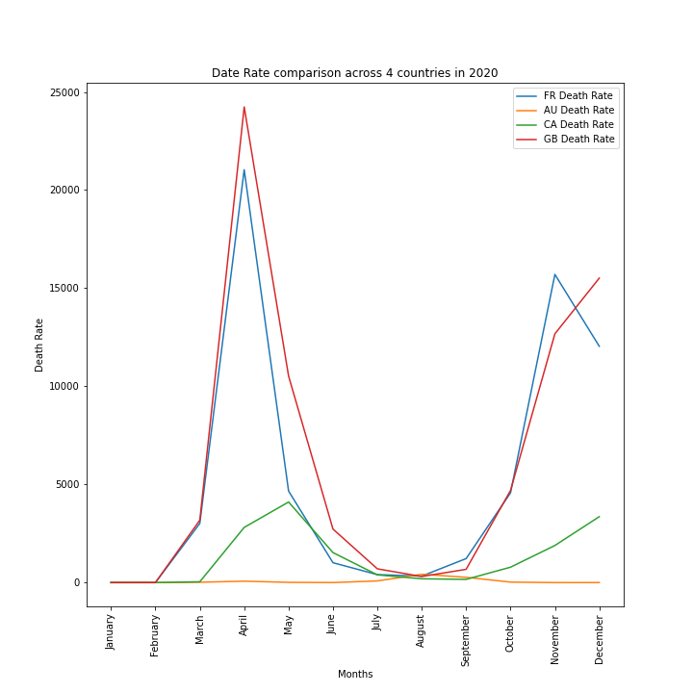

**Conclusions:**

The plot above shows the death rate in 2020 of 4 select countries: France (FR), Australia (AU), Canada (CA) and Great Britain (GB). A close look at the plot shows that from January up to February, there were no reported deaths as the covid outbreak was just begun and people were just showing symptoms of Covid.

By April, there was a spike in the number of deaths in Great Britain and France while Australia had a flat or continuous death rate at that time.

By June, the date rates were reduced in all the countries on the plot, tending towards 0. However, the second wave hit in September 2020 and there was a spike in the number of deaths in Britain and France. The death rate in Canada progressed slightly without a sharp increase compared to France and Britain. Australia maintained flat date rage and there was never a spike in Covid death in Australia.

**Question 2:**

Produce graphs using two other visualization methods. Explain why you picked this

type of graph and describe what conclusions you can draw.

**Graph 1 – Pie Chart**

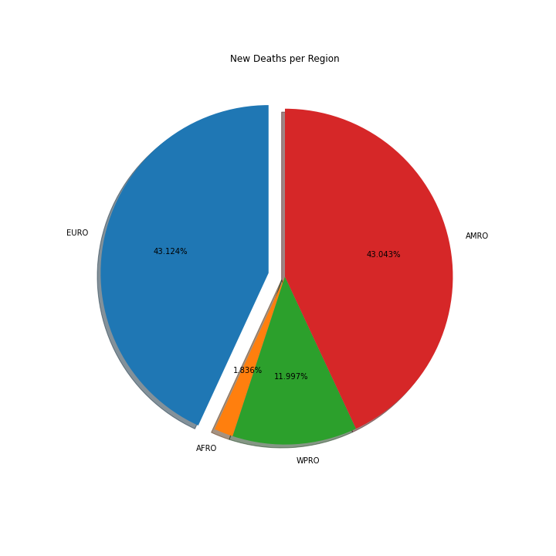

**Reason**:

I want my audience to see how the sum of covid deaths within 2022 per region can be compared to the total deaths in other regions and the whole region put together. With the pie chart, my audience would know that most of the deaths happened in France and Britain and the number of deaths is equally relative to the total number of deaths.

Also, I have a very small data set making a pie chart the best option.

**Description**:

A close look at the data shows that Britain and France had the most deaths in 2022 relative to the total deaths. Australia had the least number of deaths within the period in review.

**Graph 2 – Multiple Bar Chart**

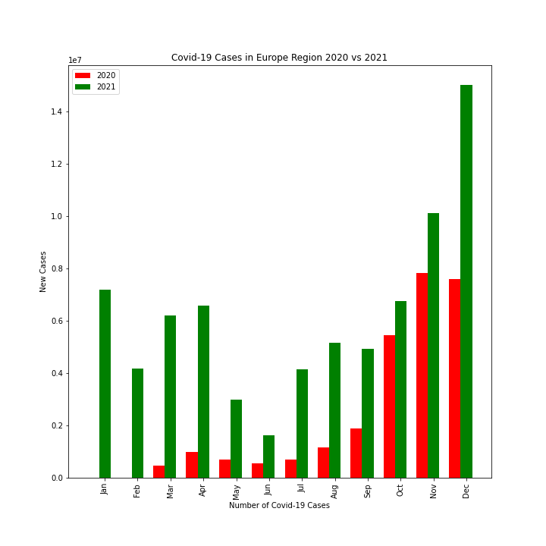

**Reason**:

I want my audience to have a visual sense of the number of Covid 19 cases in 2020 and 2021 from January to December. I choose this chart because it has a bar of the new cases in each month side by side. This makes comparison easier for my audience when they are viewing the plot. Instead of having 2 bar plots, a single plot with 2 bars for each year (2020 and 2021) would give the same result without my audience taking their eyes off the plot.

**Description**

Taking a look at the multiple bar chart, it is obvious that the number of new covid 19 cases in 2021 each month is more than the number of covid 19 cases in 2020.